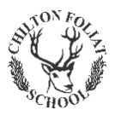

**CHILTON FOLIAT PRIMARY SCHOOL**

**Happy Christmas to all families,**

**with love from Fallow Class.**

